<https://www.thatjeffsmith.com/archive/2018/11/building-a-web-service-for-uploading-and-downloading-files-the-video/>

<https://www.youtube.com/watch?v=n9xy0GF1TYc&t=265s>

<https://www.oracle.com/cloud/>

Cloud Account Name => oracleapexoci

Oracle SSO => oracleidentitycloudservice

Oracle Account Password = FuckYouOracle1!

Database Actions

I have an admin and miso schema

Epfy44yqE_WEB

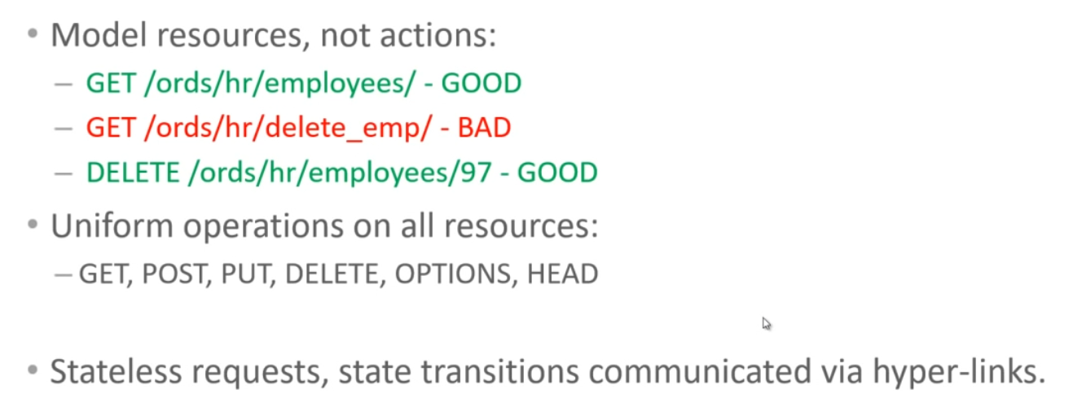

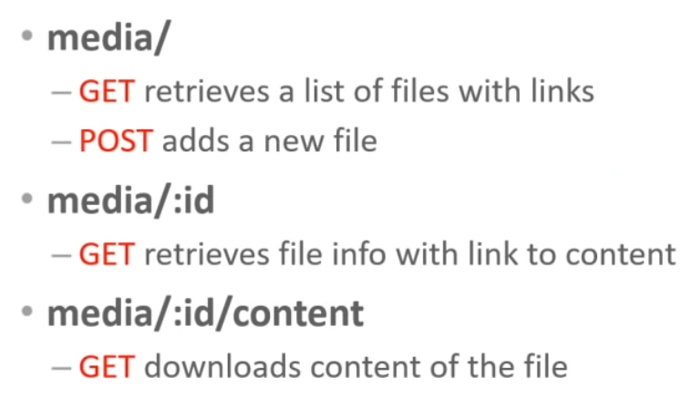

Where id is the pk

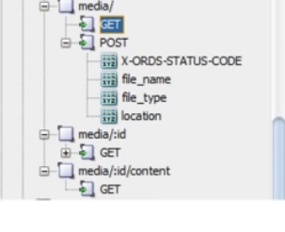

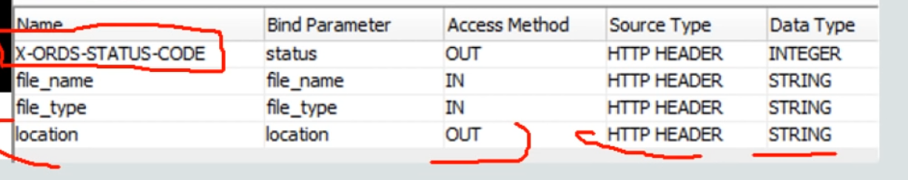

Miso

Miso/Epfy44yqE_WEB

CREATE TABLE "DW_MEDIA_UP_DOWN_FILES"

( "ID" NUMBER(*,0) GENERATED ALWAYS AS IDENTITY MINVALUE 1

MAXVALUE 9999999999999999999999999999 INCREMENT BY 1 START WITH 1

CACHE 20 NOORDER NOCYCLE NOKEEP NOSCALE NOT NULL ENABLE,

"FILE_NAME" VARCHAR2(256 BYTE) NOT NULL ENABLE,

"CONTENT_TYPE" VARCHAR2(256 BYTE) NOT NULL ENABLE,

"CONTENT" BLOB NOT NULL ENABLE,

Source_desc varchar2(4000) ,

CONSTRAINT "DW_MEDIA_UP_DOWN_FILES_PK" PRIMARY KEY ("ID")

);

----

BEGIN

ORDS.DEFINE_MODULE(

p_module_name => 'whitecastle',

p_base_path => '/fileup/',

p_items_per_page => 25,

p_status => 'PUBLISHED',

p_comments => NULL);

ORDS.DEFINE_TEMPLATE(

p_module_name => 'whitecastle',

p_pattern => 'DW_MEDIA_UP_DOWN_FILES/',

p_priority => 0,

p_etag_type => 'HASH',

p_etag_query => NULL,

p_comments => NULL);

ORDS.DEFINE_HANDLER(

p_module_name => 'whitecastle',

p_pattern => 'DW_MEDIA_UP_DOWN_FILES/',

p_method => 'POST',

p_source_type => 'plsql/block',

p_items_per_page => 0,

p_mimes_allowed => '',

p_comments => NULL,

p_source =>

'declare

image_id integer;

begin

insert into DW_MEDIA_UP_DOWN_FILES (file_name, content_type, content, source_Desc )

values (:file_name,:file_type,:body, ''WHITECASTLE_UP_1'') -- :body is defined by ORDS

returning id into image_id;

:status := 201; -- http status code

:location := ''./'' || image_id; -- included in the response to access the new record

end;'

);

ORDS.DEFINE_PARAMETER(

p_module_name => 'whitecastle',

p_pattern => 'DW_MEDIA_UP_DOWN_FILES/',

p_method => 'POST',

p_name => 'X-ORDS-STATUS-CODE',

p_bind_variable_name => 'status',

p_source_type => 'HEADER',

p_param_type => 'INT',

p_access_method => 'OUT',

p_comments => NULL);

ORDS.DEFINE_PARAMETER(

p_module_name => 'whitecastle',

p_pattern => 'DW_MEDIA_UP_DOWN_FILES/',

p_method => 'POST',

p_name => 'file_name',

p_bind_variable_name => 'file_name',

p_source_type => 'HEADER',

p_param_type => 'STRING',

p_access_method => 'IN',

p_comments => NULL);

ORDS.DEFINE_PARAMETER(

p_module_name => 'whitecastle',

p_pattern => 'DW_MEDIA_UP_DOWN_FILES/',

p_method => 'POST',

p_name => 'file_type',

p_bind_variable_name => 'file_type',

p_source_type => 'HEADER',

p_param_type => 'STRING',

p_access_method => 'IN',

p_comments => NULL);

ORDS.DEFINE_PARAMETER(

p_module_name => 'whitecastle',

p_pattern => 'DW_MEDIA_UP_DOWN_FILES/',

p_method => 'POST',

p_name => 'location',

p_bind_variable_name => 'location',

p_source_type => 'HEADER',

p_param_type => 'STRING',

p_access_method => 'OUT',

p_comments => NULL);

ORDS.DEFINE_HANDLER(

p_module_name => 'whitecastle',

p_pattern => 'DW_MEDIA_UP_DOWN_FILES/',

p_method => 'GET',

p_source_type => 'json/collection',

p_items_per_page => 25,

p_mimes_allowed => '',

p_comments => NULL,

p_source =>

'select ID ,

FILE_NAME ,

CONTENT_TYPE,

''./'' || id "$record" -- the $ tells ORDS to render this as a LINK

from DW_MEDIA_UP_DOWN_FILES

order by id asc -- optional if you want insertion order'

);

ORDS.DEFINE_TEMPLATE(

p_module_name => 'whitecastle',

p_pattern => 'DW_MEDIA_UP_DOWN_FILES/:id',

p_priority => 0,

p_etag_type => 'HASH',

p_etag_query => NULL,

p_comments => NULL);

ORDS.DEFINE_HANDLER(

p_module_name => 'whitecastle',

p_pattern => 'DW_MEDIA_UP_DOWN_FILES/:id',

p_method => 'GET',

p_source_type => 'json/item',

p_items_per_page => 25,

p_mimes_allowed => '',

p_comments => NULL,

p_source =>

'select FILE_NAME,

CONTENT_TYPE,

ID || ''/content'' "$file"

from DW_MEDIA_UP_DOWN_FILES

where ID = :id'

);

ORDS.DEFINE_TEMPLATE(

p_module_name => 'whitecastle',

p_pattern => 'DW_MEDIA_UP_DOWN_FILES/:id/content',

p_priority => 0,

p_etag_type => 'HASH',

p_etag_query => NULL,

p_comments => NULL);

ORDS.DEFINE_HANDLER(

p_module_name => 'whitecastle',

p_pattern => 'DW_MEDIA_UP_DOWN_FILES/:id/content',

p_method => 'GET',

p_source_type => 'resource/lob',

p_items_per_page => 25,

p_mimes_allowed => '',

p_comments => NULL,

p_source =>

'select CONTENT_TYPE,

CONTENT

from DW_MEDIA_UP_DOWN_FILES

where ID = :id'

);

COMMIT;

END;

<https://gd49ef7d5e3cd2d-db202110212330.adb.us-phoenix-1.oraclecloudapps.com/ords/miso/open-api-catalog/fileup/>

{

"swagger":"2.0",

"info":{

"title":"ORDS generated API for whitecastle",

"version":"1.0.0"

},

"host":"gd49ef7d5e3cd2d-db202110212330.adb.us-phoenix-1.oraclecloudapps.com",

"basePath":"/ords/miso/fileup",

"schemes":[

"https"

],

"produces":[

"application/json"

],

"paths":{

"/DW_MEDIA_UP_DOWN_FILES/":{

"post":{

"description":"Create a new record on whitecastle",

"responses":{

"201":{

"description":"The successfully created record.",

"schema":{

"type":"object",

"properties":{

}

}

}

},

"parameters":[

{

"name":"file_name",

"in":"header",

"type":"string",

"required":true

},

{

"name":"file_type",

"in":"header",

"type":"string",

"required":true

},

{

"name":"payload",

"in":"body",

"required":true,

"schema":{

"$ref":"#/definitions/whitecastle_ITEM"

}

}

]

},

"get":{

"description":"Retrieve records from whitecastle",

"produces":[

"application/json"

],

"responses":{

"200":{

"description":"The queried record.",

"schema":{

"type":"object",

"properties":{

"items":{

"type":"array",

"items":{

"type":"object",

"properties":{

"$record":{

"$ref":"#/definitions/VARCHAR2"

},

"content_type":{

"$ref":"#/definitions/VARCHAR2"

},

"file_name":{

"$ref":"#/definitions/VARCHAR2"

},

"id":{

"$ref":"#/definitions/NUMBER"

}

}

}

}

}

}

}

},

"parameters":[

]

}

},

"/DW_MEDIA_UP_DOWN_FILES/{id}":{

"get":{

"description":"Retrieve a record from whitecastle",

"produces":[

"application/json"

],

"responses":{

"200":{

"description":"The queried record.",

"schema":{

"type":"object",

"properties":{

"$file":{

"$ref":"#/definitions/VARCHAR2"

},

"content_type":{

"$ref":"#/definitions/VARCHAR2"

},

"file_name":{

"$ref":"#/definitions/VARCHAR2"

}

}

}

}

},

"parameters":[

{

"name":"id",

"in":"path",

"required":true,

"type":"string",

"description":"implicit",

"pattern":"^[^/]+$"

}

]

}

},

"/DW_MEDIA_UP_DOWN_FILES/{id}/content":{

"get":{

"description":"Retrieve a record from whitecastle",

"produces":[

"content/unknown"

],

"responses":{

"200":{

"description":"The queried record.",

"schema":{

"type":"object",

"properties":{

}

}

}

},

"parameters":[

{

"name":"id",

"in":"path",

"required":true,

"type":"string",

"description":"implicit",

"pattern":"^[^/]+$"

}

]

}

}

},

"definitions":{

"NUMBER":{

"type":"number"

},

"STRING":{

"type":"string"

},

"VARCHAR2":{

"type":"string"

},

"whitecastle_ITEM":{

"properties":{

"file_name":{

"type":"string"

},

"file_type":{

"type":"string"

},

"body":{

"type":"string"

}

}

}

}

}

Select REST BELOW:

Select Modules

Select White Castle Elipses

Under templates:

For the first Template

DW_MEDIA_UP_DOWN_FILES/

"href":<https://gd49ef7d5e3cd2d-db202110212330.adb.us-phoenix-1.oraclecloudapps.com/ords/miso/fileup/DW_MEDIA_UP_DOWN_FILES/>

The apis call for both a get and a post:

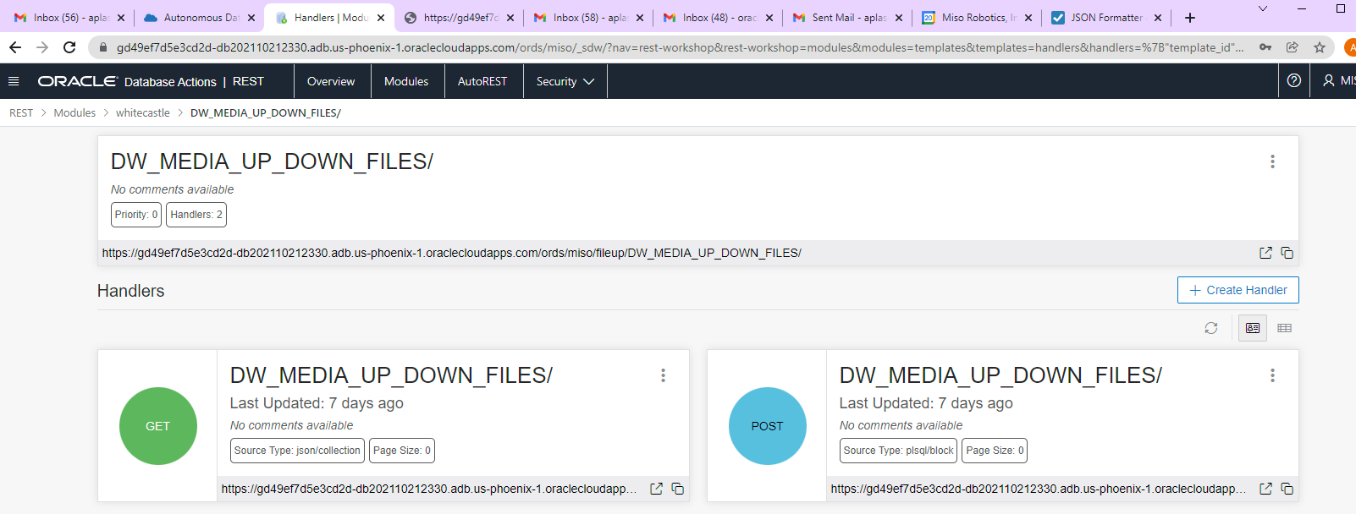

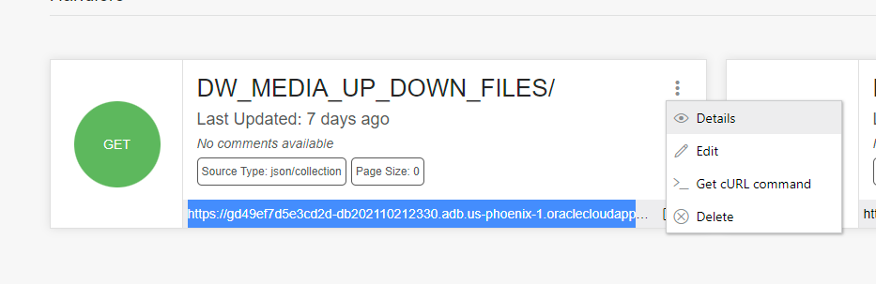

Upon click on details we see this.

curl --location \  
'https://gd49ef7d5e3cd2d-db202110212330.adb.us-phoenix-1.oraclecloudapps.com/ords/miso/fileup/DW_MEDIA_UP_DOWN_FILES/'

C:\>curl --ssl-no-revoke "https://gd49ef7d5e3cd2d-db202110212330.adb.us-phoenix-1.oraclecloudapps.com/ords/miso/fileup/DW_MEDIA_UP_DOWN_FILES/"

{"items":[],"hasMore":false,"limit":0,"offset":0,"count":0,"links":[{"rel":"self","href":"https://gd49ef7d5e3cd2d-db202110212330.adb.us-phoenix-1.oraclecloudapps.com/ords/miso/fileup/DW_MEDIA_UP_DOWN_FILES/"},{"rel":"edit","href":"https://gd49ef7d5e3cd2d-db202110212330.adb.us-phoenix-1.oraclecloudapps.com/ords/miso/fileup/DW_MEDIA_UP_DOWN_FILES/"},{"rel":"describedby","href":"https://gd49ef7d5e3cd2d-db202110212330.adb.us-phoenix-1.oraclecloudapps.com/ords/miso/metadata-catalog/fileup/DW_MEDIA_UP_DOWN_FILES/"}]}

declare

 image_id integer;

begin

 insert into DW_MEDIA_UP_DOWN_FILES (file_name, content_type, content, source_Desc )

             values  (:file_name,:file_type,:body,’’WHITECASTLE_UP_1’’) -- :body is defined by ORDS

             returning id into image_id;

 :status := 201; -- http status code

 :location := './' || image_id; -- included in the response to access the new record

end;

Close

curl --location --request POST 'https://gd49ef7d5e3cd2d-db202110212330.adb.us-phoenix-1.oraclecloudapps.com/ords/miso/fileup/DW_MEDIA_UP_DOWN_FILES/' --header 'Content Type: application/json' \  
--data-binary '{  
  "file_name": "<VALUE>",  
  "file_type": "<VALUE>",  
  "status": "<VALUE>",  
  "location": "<VALUE>"   
}'

Bind variables



:body is the body of the post, get that data and put it into a blob.

:status is the return code hard coded

:location is the url link of the record just added in. A special name is set to X-ORDS-STATUS-CODE.

:id is automatically bound , case sensitive

Set to media resource the context_type .

https://gd49ef7d5e3cd2d-db202110212330.adb.us-phoenix-1.oraclecloudapps.com/ords/miso/open-api-catalog/fileup/

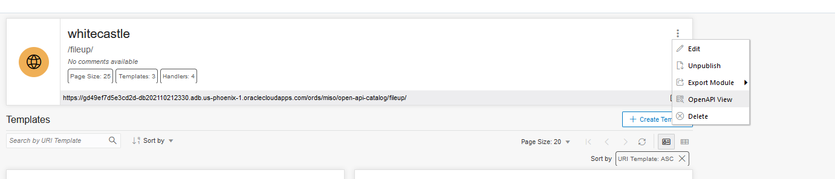

curl -X ”POST” ”https://gd49ef7d5e3cd2d-db202110212330.adb.us-phoenix-1.oraclecloudapps.com/ords/miso/fileup/DW_MEDIA_UP_DOWN_FILES/” ^

-H ”accept: application/json” -H ”file_name: a.a” -H ”file_type: text” -H ”Content-Type: application/json” ^

-d ”{ "file_name": "a.a", "file_type": "text", "body": "string" }”

C:\pos> curl --ssl-no-revoke --request "POST" "https://gd49ef7d5e3cd2d-db202110212330.adb.us-phoenix-1.oraclecloudapps.com/ords/miso/fileup/DW_MEDIA_UP_DOWN_FILES/" ^

-H "accept: application/json" -H "file_name: a.a" -H "file_type: text" -H "Content-Type: application/json" ^

-d "{ "file_name": "a.a", "file_type": "text", "body": "string" }" -v

C:\pos>curl --ssl-no-revoke --request "POST" "https://gd49ef7d5e3cd2d-db202110212330.adb.us-phoenix-1.oraclecloudapps.com/ords/miso/fileup/DW_MEDIA_UP_DOWN_FILES/" ^

More? -H "accept: application/json" -H "file_name: a.a" -H "file_type: text" -H "Content-Type: application/json" ^

More? -d "{ "file_name": "a.a", "file_type": "text", "body": "string" }" -v

Note: Unnecessary use of -X or --request, POST is already inferred.

* Trying 138.1.118.157...

* TCP_NODELAY set

* Connected to gd49ef7d5e3cd2d-db202110212330.adb.us-phoenix-1.oraclecloudapps.com (138.1.118.157) port 443 (#0)

* schannel: SSL/TLS connection with gd49ef7d5e3cd2d-db202110212330.adb.us-phoenix-1.oraclecloudapps.com port 443 (step 1/3)

* schannel: disabled server certificate revocation checks

* schannel: sending initial handshake data: sending 229 bytes...

* schannel: sent initial handshake data: sent 229 bytes

* schannel: SSL/TLS connection with gd49ef7d5e3cd2d-db202110212330.adb.us-phoenix-1.oraclecloudapps.com port 443 (step 2/3)

* schannel: failed to receive handshake, need more data

* schannel: SSL/TLS connection with gd49ef7d5e3cd2d-db202110212330.adb.us-phoenix-1.oraclecloudapps.com port 443 (step 2/3)

* schannel: encrypted data got 3576

* schannel: encrypted data buffer: offset 3576 length 4096

* schannel: sending next handshake data: sending 126 bytes...

* schannel: SSL/TLS connection with gd49ef7d5e3cd2d-db202110212330.adb.us-phoenix-1.oraclecloudapps.com port 443 (step 2/3)

* schannel: encrypted data got 306

* schannel: encrypted data buffer: offset 306 length 4096

* schannel: SSL/TLS handshake complete

* schannel: SSL/TLS connection with gd49ef7d5e3cd2d-db202110212330.adb.us-phoenix-1.oraclecloudapps.com port 443 (step 3/3)

* schannel: stored credential handle in session cache

> POST /ords/miso/fileup/DW_MEDIA_UP_DOWN_FILES/ HTTP/1.1

> Host: gd49ef7d5e3cd2d-db202110212330.adb.us-phoenix-1.oraclecloudapps.com

> User-Agent: curl/7.55.1

> accept: application/json

> file_name: a.a

> file_type: text

> Content-Type: application/json

> Content-Length: 49

>

* upload completely sent off: 49 out of 49 bytes

* schannel: client wants to read 102400 bytes

* schannel: encdata_buffer resized 103424

* schannel: encrypted data buffer: offset 0 length 103424

* schannel: encrypted data got 305

* schannel: encrypted data buffer: offset 305 length 103424

* schannel: decrypted data length: 242

* schannel: decrypted data added: 242

* schannel: decrypted data cached: offset 242 length 102400

* schannel: encrypted data length: 34

* schannel: encrypted data cached: offset 34 length 103424

* schannel: decrypted data length: 5

* schannel: decrypted data added: 5

* schannel: decrypted data cached: offset 247 length 102400

* schannel: encrypted data buffer: offset 0 length 103424

* schannel: decrypted data buffer: offset 247 length 102400

* schannel: schannel_recv cleanup

* schannel: decrypted data returned 247

* schannel: decrypted data buffer: offset 0 length 102400

< HTTP/1.1 201 Created

< Date: Tue, 21 Dec 2021 17:40:24 GMT

< Transfer-Encoding: chunked

< Connection: keep-alive

< Location: https://gd49ef7d5e3cd2d-db202110212330.adb.us-phoenix-1.oraclecloudapps.com/ords/miso/fileup/DW_MEDIA_UP_DOWN_FILES/1

<

* Connection #0 to host gd49ef7d5e3cd2d-db202110212330.adb.us-phoenix-1.oraclecloudapps.com left intact

C:\pos> curl --ssl-no-revoke --request "POST" "https://gd49ef7d5e3cd2d-db202110212330.adb.us-phoenix-1.oraclecloudapps.com/ords/miso/fileup/DW_MEDIA_UP_DOWN_FILES/" -H "accept: application/json" -H "file_name: a.a" -H "file_type: text" -H "Content-Type: application/json" -d "{ \"file_name\": \"a.a\", \"file_type\": \"text\", \"body\": \"string\" }"

{

"code": "UserDefinedResourceError",

"title": "User Defined Resource Error",

"message": "The request could not be processed due to an error in a user defined resource",

"o:errorCode": "ORDS-25001",

"cause": "An error occurred when evaluating the SQL statement associated with this resource. SQL Error Code 6550, Error Message: ORA-06550: line 5, column 41:\nPL/SQL: ORA-01756: quoted string not properly terminated\nORA-06550: line 4, column 2:\nPL/SQL: SQL Statement ignored\n",

"action": "Ask the user defined resource author to check the SQL statement is correctly formed and executes without error",

"type": "tag:oracle.com,2020:error/UserDefinedResourceError",

"instance": "tag:oracle.com,2020:ecid/5bd330c10a51d3d6a4f7d328d9489226"

}

Not sure what I’d doping wrong.

C:\pos>curl --ssl-no-revoke --request "POST" "https://gd49ef7d5e3cd2d-db202110212330.adb.us-phoenix-1.oraclecloudapps.com/ords/miso/fileup/DW_MEDIA_UP_DOWN_FILES/" ^

More? -H "accept: application/json" -H "file_name: a.a" -H "file_type: text" -H "Content-Type: application/json" ^

More? --data-binary "@c:\pos\a.a"

create function jeff_clobfromblob(p_blob blob) return clob is

      l_clob         clob;

      l_dest_offsset integer := 1;

      l_src_offsset  integer := 1;

      l_lang_context integer := dbms_lob.default_lang_ctx;

      l_warning      integer;

   begin

      if p_blob is null then

         return null;

      end if;

      dbms_lob.createTemporary(lob_loc => l_clob

                              ,cache   => false);

      dbms_lob.converttoclob(dest_lob     => l_clob

                            ,src_blob     => p_blob

                            ,amount       => dbms_lob.lobmaxsize

                            ,dest_offset  => l_dest_offsset

                            ,src_offset   => l_src_offsset

                            ,blob_csid    => dbms_lob.default_csid

                            ,lang_context => l_lang_context

                            ,warning      => l_warning);

      return l_clob;

   end;

   select id, file_name, content_type, jeff_clobfromblob(content ) clob_content

    from dw_media_up_Down_files;

delete from dw_media_up_Down_files;

C:\pos>curl --ssl-no-revoke --request "POST"  "<https://gd49ef7d5e3cd2d-db202110212330.adb.us-phoenix-1.oraclecloudapps.com/ords/miso/fileup/DW_MEDIA_UP_DOWN_FILES/>" ^

  -H "accept: application/json" -H "file_name: a.a"  -H "file_type: text" -H "Content-Type: application/json" ^

 --data-binary "@c:\pos\a.a"  -v

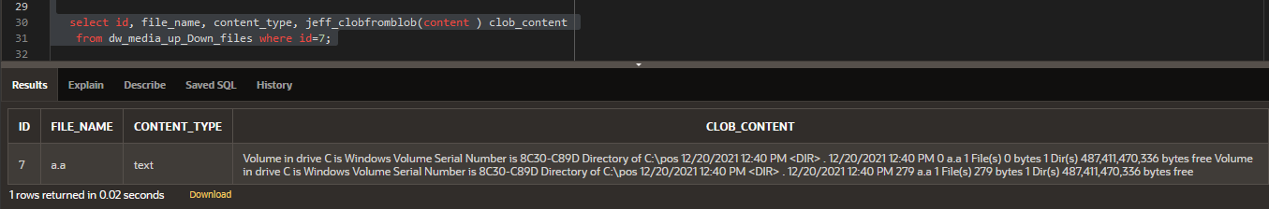

C:\pos>curl --ssl-no-revoke --request "POST"  "<https://gd49ef7d5e3cd2d-db202110212330.adb.us-phoenix-1.oraclecloudapps.com/ords/miso/fileup/DW_MEDIA_UP_DOWN_FILES/>" ^  
More? -H "accept: application/json" -H "file_name: a.a"  -H "file_type: text" -H "Content-Type: application/json" ^  
More? --data-binary "@c:\pos\a.a" -v  
Note: Unnecessary use of -X or --request, POST is already inferred.  
*   Trying 138.1.118.157...  
* TCP_NODELAY set  
* Connected to [gd49ef7d5e3cd2d-db202110212330.adb.us-phoenix-1.oraclecloudapps.com](http://gd49ef7d5e3cd2d-db202110212330.adb.us-phoenix-1.oraclecloudapps.com) (138.1.118.157) port 443 (#0)  
* schannel: SSL/TLS connection with [gd49ef7d5e3cd2d-db202110212330.adb.us-phoenix-1.oraclecloudapps.com](http://gd49ef7d5e3cd2d-db202110212330.adb.us-phoenix-1.oraclecloudapps.com) port 443 (step 1/3)  
* schannel: disabled server certificate revocation checks  
* schannel: sending initial handshake data: sending 229 bytes...  
* schannel: sent initial handshake data: sent 229 bytes  
* schannel: SSL/TLS connection with [gd49ef7d5e3cd2d-db202110212330.adb.us-phoenix-1.oraclecloudapps.com](http://gd49ef7d5e3cd2d-db202110212330.adb.us-phoenix-1.oraclecloudapps.com) port 443 (step 2/3)  
* schannel: failed to receive handshake, need more data  
* schannel: SSL/TLS connection with [gd49ef7d5e3cd2d-db202110212330.adb.us-phoenix-1.oraclecloudapps.com](http://gd49ef7d5e3cd2d-db202110212330.adb.us-phoenix-1.oraclecloudapps.com) port 443 (step 2/3)  
* schannel: encrypted data got 3576  
* schannel: encrypted data buffer: offset 3576 length 4096  
* schannel: sending next handshake data: sending 126 bytes...  
* schannel: SSL/TLS connection with [gd49ef7d5e3cd2d-db202110212330.adb.us-phoenix-1.oraclecloudapps.com](http://gd49ef7d5e3cd2d-db202110212330.adb.us-phoenix-1.oraclecloudapps.com) port 443 (step 2/3)  
* schannel: encrypted data got 306  
* schannel: encrypted data buffer: offset 306 length 4096  
* schannel: SSL/TLS handshake complete  
* schannel: SSL/TLS connection with [gd49ef7d5e3cd2d-db202110212330.adb.us-phoenix-1.oraclecloudapps.com](http://gd49ef7d5e3cd2d-db202110212330.adb.us-phoenix-1.oraclecloudapps.com) port 443 (step 3/3)  
* schannel: stored credential handle in session cache  
> POST /ords/miso/fileup/DW_MEDIA_UP_DOWN_FILES/ HTTP/1.1  
> Host: [gd49ef7d5e3cd2d-db202110212330.adb.us-phoenix-1.oraclecloudapps.com](http://gd49ef7d5e3cd2d-db202110212330.adb.us-phoenix-1.oraclecloudapps.com)  
> User-Agent: curl/7.55.1  
> accept: application/json  
> file_name: a.a  
> file_type: text  
> Content-Type: application/json  
> Content-Length: 558  
>  
* upload completely sent off: 558 out of 558 bytes  
* schannel: client wants to read 102400 bytes  
* schannel: encdata_buffer resized 103424  
* schannel: encrypted data buffer: offset 0 length 103424  
* schannel: encrypted data got 305  
* schannel: encrypted data buffer: offset 305 length 103424  
* schannel: decrypted data length: 242  
* schannel: decrypted data added: 242  
* schannel: decrypted data cached: offset 242 length 102400  
* schannel: encrypted data length: 34  
* schannel: encrypted data cached: offset 34 length 103424  
* schannel: decrypted data length: 5  
* schannel: decrypted data added: 5  
* schannel: decrypted data cached: offset 247 length 102400  
* schannel: encrypted data buffer: offset 0 length 103424  
* schannel: decrypted data buffer: offset 247 length 102400  
* schannel: schannel_recv cleanup  
* schannel: decrypted data returned 247  
* schannel: decrypted data buffer: offset 0 length 102400  
< HTTP/1.1 201 Created  
< Date: Tue, 21 Dec 2021 18:40:31 GMT  
< Transfer-Encoding: chunked  
< Connection: keep-alive  
**< Location:** [**https://gd49ef7d5e3cd2d-db202110212330.adb.us-phoenix-1.oraclecloudapps.com/ords/miso/fileup/DW_MEDIA_UP_DOWN_FILES/7**](https://gd49ef7d5e3cd2d-db202110212330.adb.us-phoenix-1.oraclecloudapps.com/ords/miso/fileup/DW_MEDIA_UP_DOWN_FILES/7)  
<  
* Connection #0 to host [gd49ef7d5e3cd2d-db202110212330.adb.us-phoenix-1.oraclecloudapps.com](http://gd49ef7d5e3cd2d-db202110212330.adb.us-phoenix-1.oraclecloudapps.com) left intact

=========================

C:\pos>type a.a  
 Volume in drive C is Windows  
 Volume Serial Number is 8C30-C89D  
  
 Directory of C:\pos  
  
12/20/2021  12:40 PM    <DIR>          .  
12/20/2021  12:40 PM                 0 a.a  
               1 File(s)              0 bytes  
               1 Dir(s)  487,411,470,336 bytes free  
 Volume in drive C is Windows  
 Volume Serial Number is 8C30-C89D  
  
 Directory of C:\pos  
  
12/20/2021  12:40 PM    <DIR>          .  
12/20/2021  12:40 PM               279 a.a  
               1 File(s)            279 bytes

               1 Dir(s)  487,411,470,336 bytes free

====================

That worked thank you !!

